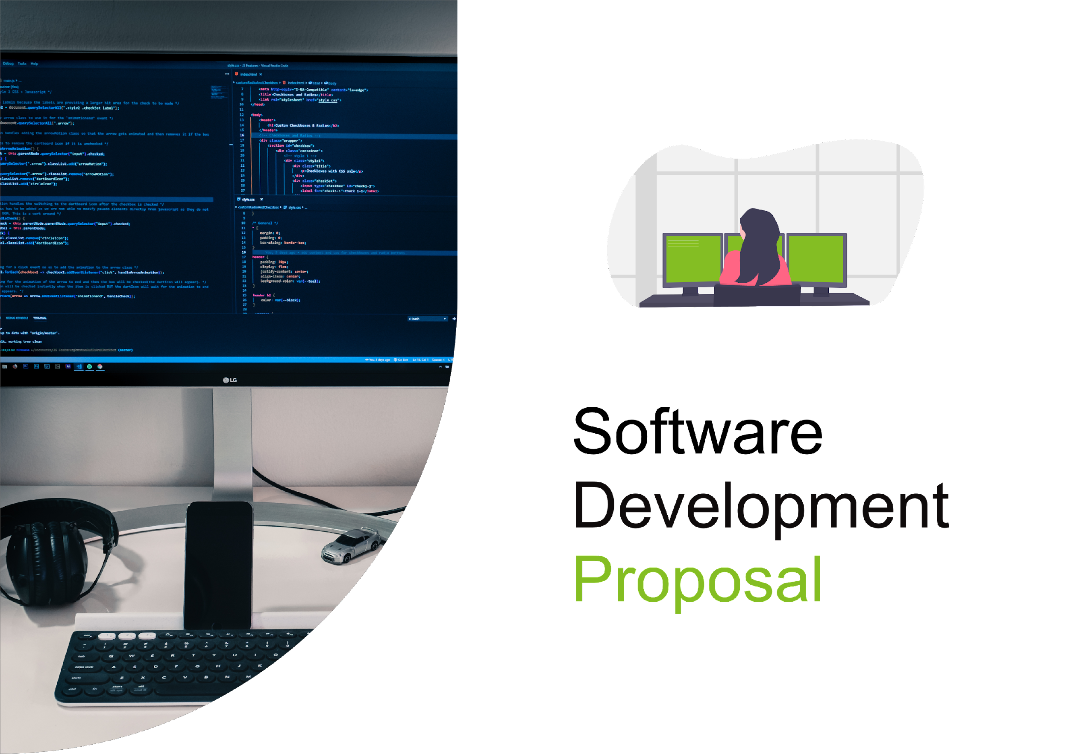

1. Overview

While Deloitte is widely recognised as one of the leading "big four" accounting firms, our capabilities extend far beyond that realm. We take pride in our proficiency and diverse range of services, including the development of intricate software solutions for our clients. With a dedicated team of software development experts, we have successfully assisted numerous clients across a multitude of projects, consistently delivering top-tier software craftsmanship.

Enclosed in this document is our comprehensive Software Development Proposal tailored for Daikibo's Telemetry Live Dashboard.

2. Scope

Below are the primary features of the project:

* Creation of a secure, private dashboard displaying the health status of nine telemetry-enabled machines across each of Daikibo's four factories.
* Limited access to the dashboard within Daikibo's Intranet/VPN network.
* Implementation of authentication synced with the internal authentication server, eliminating the need for users to create individual accounts.
* Development of a single-page dashboard showcasing the current statuses of all monitored devices.
* Incorporation of collapsible/expandable views at both factory and device levels, facilitating the display of status history.

For a visual reference, please consult the wireframe image provided on the subsequent page. Note that this image serves as a mock-up representation of functionality and is subject to change in the final design.

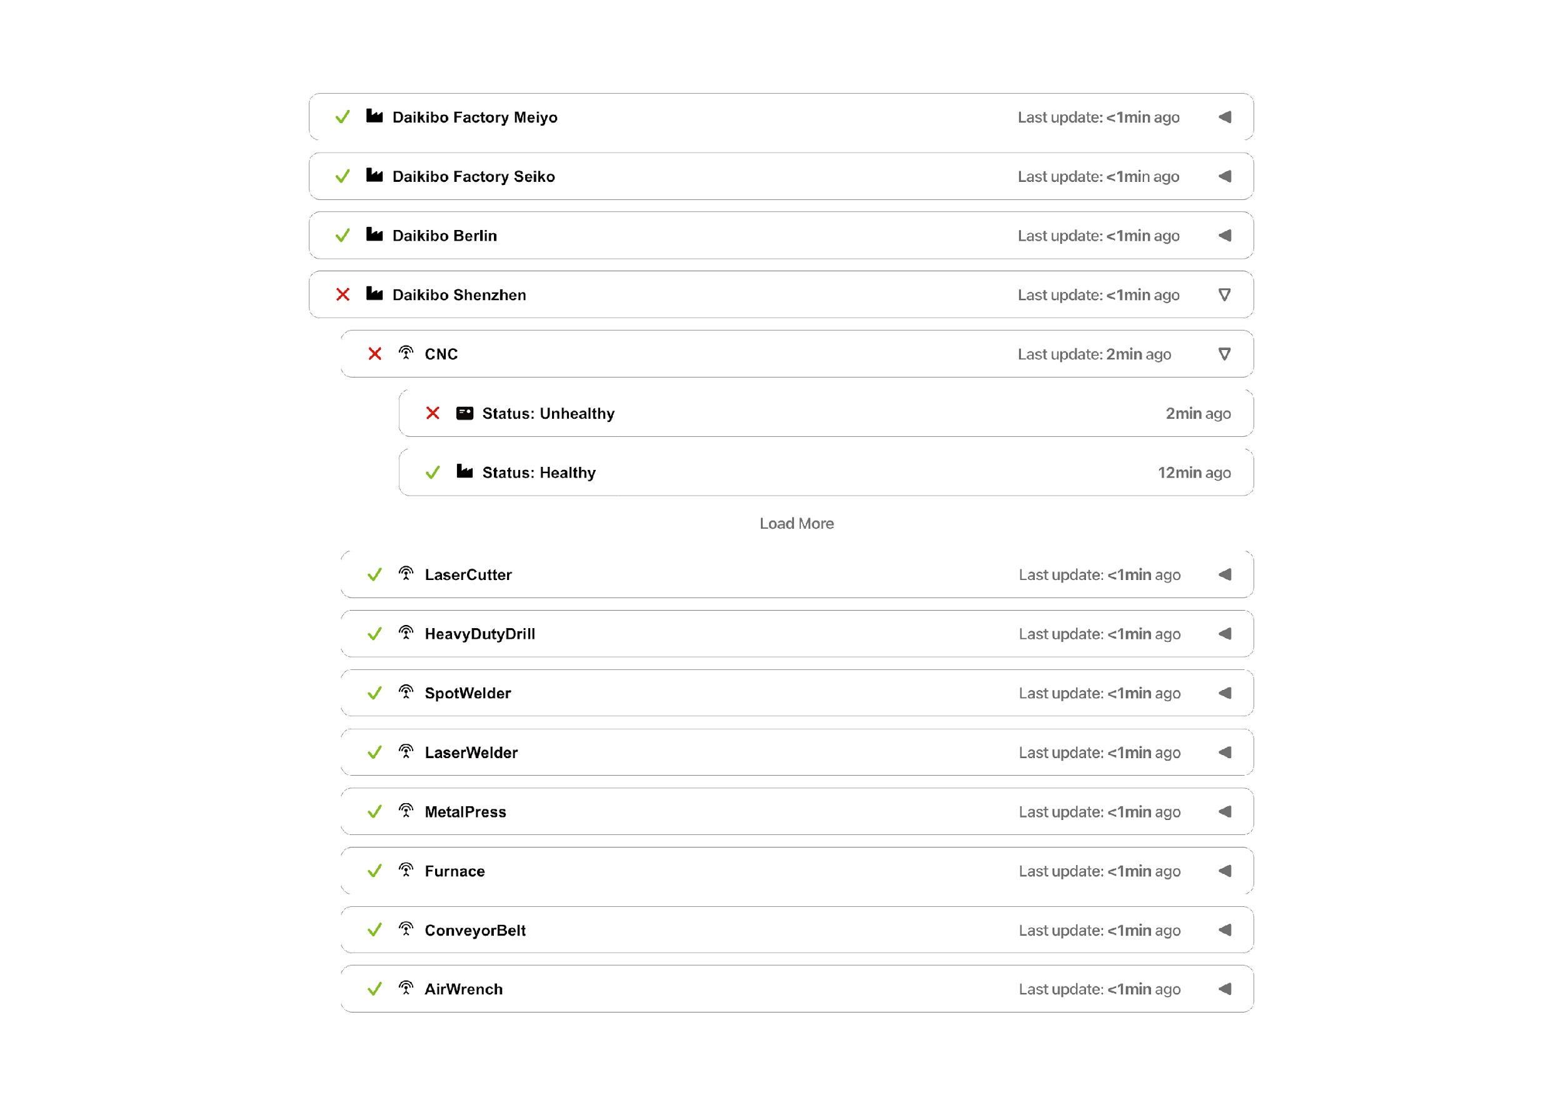

3. Estimate

We propose the following allocation of man-hours for the project:

* Design: 40 man-hours
* Development: 160 man-hours
* Integration: 80 man-hours
* **Total:** 280 man-hours

Given our internal team composition, consisting of 2 software engineers and 1 graphic designer, we will distribute the workload accordingly. However, it's important to note that we will require the assistance of at least 1 DevOps engineer from Daikibo to facilitate the handoff of the finished product and provide access to authentication and telemetry databases/servers.

4. Timeline

1. [1st of February 2024] **Design starts**
2. [8th of February 2024] **Design is circulated to Daikibo for feedback**
3. [12th of February 2024] **Design is finalised and Development starts**
4. [1st of March 2024] **Development is done and v1 of the product is demonstrated to Daikibo**
5. [8th of March 2024] **Development is finalised and Integration starts**
6. [22nd of March 2024] **Integration is completed.**

5. Support

The primary focus of this proposal is on the development of the project. However, following the successful deployment of the product within Daikibo's infrastructure, we commit to providing ongoing support.

Our support system enables you to submit tickets for assistance, ensuring prompt attention to any issues that may arise. It's important to note that the estimated work outlined in this proposal does not encompass continuous support. Any future bug fixes, updates, and improvements will be handled separately and invoiced accordingly.